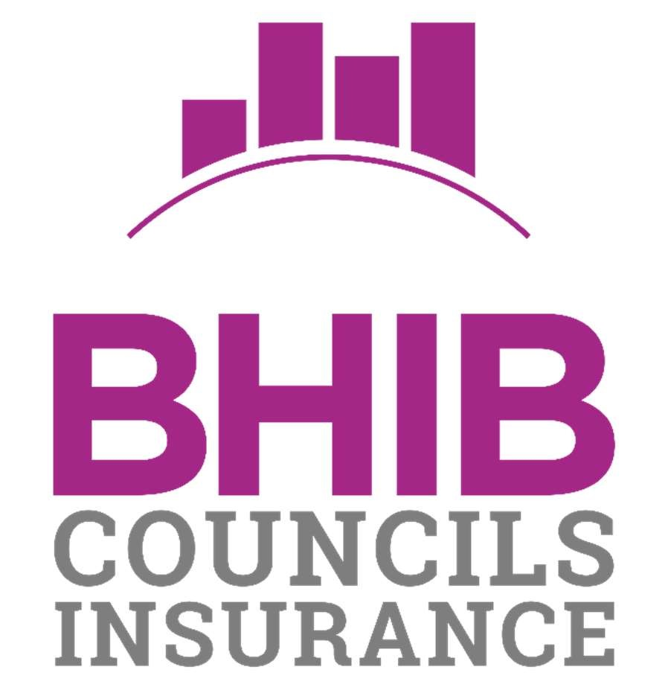

Important Notices & Information

BHIB Councils Insurance - Important Notices & Information v8.0 January 2023

Important Notices – Local Councils

We are continually looking at ways to improve the scope of our services including additional cover options which can be arranged and providing important updates to help you with managing your insurance arrangements.

In this bulletin we are highlighting the following important issues:

- Risk Management and Resilience – Guidance and advice for your council.

- Insurance premiums – Why do premiums increase?

- Employers Liability – Providing the necessary information for the Employers Liability Tracing Office (ELTO). If you haven’t already replied, your reply is required – please follow the guidelines provided.

- Cyber and Hacking Risks - Vitally important insurance options, to assist you in the event of a cyber-attack.

- Notifying Claims – Quick and efficient claims notification services.

Please take a few minutes to read and reply. If you have any questions or comments please contact the BHIB Councils team on 0330 013 0036, or via email to enquiries@bhibcouncils.co.uk

For additional information and topical articles on risk management and additional services, please visit our dedicated website http://www.bhibinsurance.co.uk/bhibcouncils/

Risk Management and Resilience

At BHIB we continually broadcast topical risk management guidance and advice to our Local Councils customers, via our website. If you haven’t taken a look recently, click the link below:

BHIB Councils News & Advice

New articles are posted frequently. Here is a selection of titles that might be of interest, or of practical use to you:

- Risk Assessment Toolkit
- Managing your Buildings and Pipes during Winter: Risk Advice for Local and Parish Councils
- Display Screen Equipment (DSE) – Self Assessment Form for Councils
- Making your council website WCAG 2.1 AA compliant – what you need to know
- Holding Community Events
- Reopening leisure centres, indoor gyms and swimming pools after COVID-19 – risk assessments for councils
- Pond Risk Assessment

It’s important to stay abreast of news relevant to the sector. If you have an article you think might be of interest to your colleagues around the UK, let us know. If there is a topic you might want us to explore for you, relevant to risk management, risk assessments or risk transfer, please send in your ideas and we will set about composing a suitable and shareable article.

Insurance premiums – Why do premiums increase?

General insurance premiums have been rising recently. Many of us are now experiencing something which has not happened very often, if at all, in almost 20 years. A combination of poor long term provisioning by insurance companies, coupled with sustained low interest rates, low investment returns, and of course the recent impact of the global pandemic and Brexit, means that there simply isn’t enough premium in the UK pot, to pay all the claims. Insurance premiums have not kept pace with the rising costs of medical care, motor repairs and property construction. In all honesty, the signs were already there before COVID happened along. Sometimes, something has to give.

We have worked hard with Aviva, to keep any rate increases to a minimum, but it is inevitable that prices will have to level up from time to time, for the greater good.

It may interest you to know that most town and parish councils will still pay less premium for public liability insurance, covering the full extent of their third party legal responsibilities, within their boundaries, than most small businesses pay for PL insurance, for a single premises based operation.

Index Linking and Underinsurance

Your policy is Index Linked annually. This means that your Building and Contents values are increased automatically at each renewal, in line with UK indices and statistics that are constantly monitored by your insurers, including the Building Cost Information Service Materials Costs Index (BCIS). Recent reports show that price rises are hitting a 40 year high, mainly due to rising construction materials and labour costs, and general inflation. The increases applied to your sums insured will increase the premium you pay for those assets proportionately, therefore, you will notice some larger annual differences in the premium as those indices rise, in the short term at least.

Whilst this function provides a mechanism by which your sums insured keep pace with inflation, you must continue to review your sums insured annually, so as to ensure you are not underinsured. We recommend you obtain professional valuations for the reinstatement of your Buildings, every three years, so as to ensure your sum insured is set at the right level, avoiding the potentially damaging effects of underinsurance. BHIB can recommend professional buildings valuation service providers, some of whom can provide ‘desktop’ valuations without needing to visit the property, at a low cost. Larger, more complex properties may require a physical visit by a qualified surveyor, subject to a suitable commercial charge for the additional service. Contact the BHIB Councils team for details of the services available.

Long Term Undertakings

Over half of our BHIB Local Councils customers have now taken up our offer of a three year long term undertaking (LTU). Not only do they benefit from a small discount across each of those three years, but those customers with LTUs that do not expire until 2023, will not be affected by the current premium changes, until such time as their agreements expire. Customers who do not have a current LTU, or have one which expired during 2022, will see some relatively small fluctuations in their premiums at next renewal.

Our lengthy experience in the insurance broking world, shows that ‘hard market’ conditions such as these, rarely last too long. However, we often see additional rate increases in year two, before any levelling out becomes evident. It stands to reason then, that renewals coming up during2023 might benefit from a fresh Long Term Undertaking, despite a modest increase in the opening premium, so as to protect that from any second wave of price adjustments, during what might be a ‘difficult’ year or two. The extra discount itself will outweigh the effect of any increase in the rate, over the next three years.

It should be noted that index linked increases to Buildings and other property sums insured will mean that premiums rise proportionately every year, despite the presence of an LTU. The LTU serves to lock in the underlying rate of premium, not the level of premium itself.

Employers Liability Tracing Office

Employers’ Liability (EL) insurance was made compulsory under the Employers’ Liability (Compulsory Insurance) Act 1969. It effectively means that most employers need to purchase EL insurance in order to trade legally.

EL insurance enables employers to meet the cost of compensation should an employee suffer illness or injury related to the work they do, whether this occurs on or off-site.

The Employers’ Liability Tracing Office (ELTO) is an independent industry body comprising members who are EL insurers. ELTO is a proactive move by the insurance industry to meet its obligations to help those who have suffered injury or disease in the workplace identify the relevant insurer quickly and efficiently. Some injuries or illnesses can take many years to manifest themselves, so this is especially relevant where a company has ceased trading or there is no immediately obvious point of contact to advise the insurer for a specific cover period.

At the heart of this process is a centralised database – the Employers’ Liability Database (ELD). Claimants, claimant lawyers, employers, brokers, insurers and defendant lawyers can use the search facility where there is a specific claim in question.

The requirements for additional information are mandatory. If you haven’t already declared your Employer Reference Number (ERN) to your broker or insurer, now is the time to check and advise.

Employer Reference Number (ERN)
Each organisation operating a PAYE scheme is allocated an ERN. This is the reference number for their employees’ income tax and national insurance contributions and is also commonly referred to as ‘Employer PAYE Reference’.

ERNs are unique and no single ERN is used by more than one employer. The ERN is used as a ‘unique identifier’ for companies on the Employers’ Liability Database and therefore immediately offers opportunities to streamline the search.

Insurers will upload your ERN to the Employers’ Liability Database (ELD) along with your EL policy information. This enables anyone with a legitimate need to quickly identify the policy concerned and start the claims process as appropriate.

Subsidiary company information
If your organisation has any subsidiary companies, your insurer or broker will ask you to supply the name and ERN for each of these. In some cases, the ERN will be the same as the parent company.

Subsidiary company names are recorded because future claimants may not know the parent company name (to whom insurance is often registered); however they may know the name of the subsidiary that they worked for.

Where can I find this information?
The ERN is found on many documents including P45, P60, P45, P60, P11/D and many payslips – see images below:

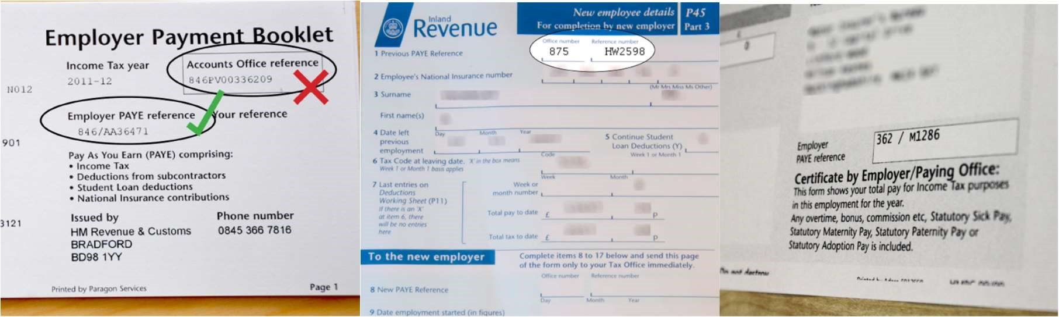

ERNs will normally begin with three numbers (representing the tax office whose catchment area the employer falls into) followed by a forward slash and then a combination of letters and numbers. e.g. 083/WY12345.

There are very few ERN exceptions
In all cases where PAYE is operated, an ERN is allocated to the employer and the ERN applies to all UK businesses employing one or more people. A minority of employers do not have an ERN, including those that:

- Pay all employees below the Lower Earnings Limit, none of the employees has another job, and none of the employees is in receipt of a state or occupational pension or other employee benefits,
or;

- Are registered in the Isle of Man, or the Channel Islands (these have no tax presence in the UK).

For more information on ERNs or the threshold limits, see the HMRC website.

How to notify BHIB
Simply call us on 0330 013 0036 or email enquiries@bhibcouncils.co.uk, quote the name of your organisation and your policy number and let us record your ERN details. It is equally important to let us know if you are exempt, for one of the reasons mentioned above. We look forward to hearing from you.

Cyber and Hacking Risks

Does your organisation value data?
You only need to watch the news to know the risk of cyber threats is greater than ever before. What was first viewed as a spike in activity is now recognised as the new normal. These high-profile attacks underline how important it is for businesses and organisations in all sectors and of all sizes to take their cyber security far more seriously. In recent months, there has been a proliferation of ‘ransomware’ attacks, which can be particularly troublesome, and costly, to overcome.

If your organisation processes sensitive data, such as credit cards, or you have intellectual property or personal information relating to your employees, customers, service users, contractors or members of the public, you need to consider your cyber risk.

If you:

- depend on having an online service portal for service users and members of the public
- share data with suppliers, contractors or IT service providers (including cloud providers)
- allow employees and volunteers to use their own devices to access and store company information

then ask yourself, what would you do if your data was compromised? How could you protect yourself?

What’s the function of cyber insurance cover?
As virtually all organisations now depend on their digital technology, online services and information to run their day-to-day affairs, a single successful cyber-attack could cause serious problems. If the personal information you hold is compromised, stolen, altered or destroyed, it could put your customers and service users at risk, have a financial impact and damage your organisation’s reputation.

And online attacks are only part of the problem. System failure and human error have an equally damaging impact.

Define what is at risk
A lot. Namely, your money, your IT equipment, your IT-based services, your information and your reputation. Cyber criminals can go after and make use of information in many forms:

- lists and databases containing names and addresses
- sensitive employee/volunteer information
- you and your customers and service users’ financial details, including funds
- deals you are making or considering
- intellectual property, such as product designs or plans

Gain control over the outcome of a cyber breach
Our Data Breach Response extension, available as an extension to your BHIB Local Councils policy from just £58.80 per year, pays up to a total of £25,000 for the following expenses that result from a breach:

- Specialist consultants or consulting engineers to investigate if a Data Security Breach has occurred and mitigate an ongoing loss

- External legal advice to manage your response to the Data Security Breach

- Notifying any Data Subject of the Data Security Breach and any regulatory body of the Data Security Breach where you are required to do so by any law or regulation

- Provision of
  - A telephone help line to assist Data Subjects after they have been notified of the
Data Security Breach
  - A credit monitoring or credit protection service to the affected Data Subjects for a period of one year provided that the offer of such service must be accepted by the
Data Subject within 12 months of the initial offer
  - Identity fraud remediation services for Data Subjects

Emergency response claims service
A 24 hour, 365 days a year claims line providing you with emergency assistance whenever it is required. When we know about your problem, we will start to put the above solutions in place.

Key policy conditions
- Access to Computer and Electronic Equipment must be authenticated by the use of individual identification and passwords.
- Equipment that is connected to the internet must be protected by a suitable firewall which is regularly maintained.
- Anti-Virus Software must be installed and automatically updated at least once a month
- A robust Data Back-up and Storage regime must be adopted
- All Personal Data must be stored and disposed of in a secure manner
- A £250 excess applies to all claims

Alternative ‘Cyber for Councils’ Insurance Cover

Our BHIB Cyber for Councils Insurance Policy offers all of the above, and much more. We can now provide tailored protection and peace of mind for Local Councils from the risks of cyber attacks and any liabilities that arise due to a breach of privacy legislation (GDPR).

In addition to an increased sum insured of £250,000, and 10 free Avast Business Pro Plus device protection licences, our policy provides the following exclusive additional benefits:
- Free EOS (European Organisation for Security) data breach alert and monitoring service
- Small Councils can work in partnership and have a joint policy with up to 3 other Councils to split the cost and share 10 free Avast Business Pro Plus device licences
- Free 1 Hour cyber/GDPR consultation with a compliance specialist, who is also a councillor ▪ BHIB Councils Insurance Cyber Risk Scorecard
Please click the link below to visit our website for further details of this alternative policy. Take a look at the Frequently Asked Questions too, as they might help you to decide on the best Cyber Insurance solution for your council.

BHIB Cyber for Councils

How to arrange cover with BHIB
To arrange a full quotation for either of these options, please contact the office on 0330 013 0036 or email us at enquiries@bhibcouncils.co.uk, quoting the name of your organisation and your policy number.

Notifying Claims

CLAIMS DELIVERY AND SUPPORT
Claims excellence delivered through dedicated teams who understand Council business. Important contact details are as follows:
Claim Type | Email | Provider | Phone | Business Hours
Property Damage | Send Email | Aviva | 0800 015 1498 | 9-5 Monday to  Friday
Liability | Send Email | Aviva | 0800 015 1498 | 9-5 Monday to  Friday
Legal Expenses | Send Email | DAS Legal | 0345 300 1899 | 24/7

Please retain this information in a safe place in the event of an incident. The details are always available on our website http://www.bhibinsurance.co.uk/bhibcouncils/

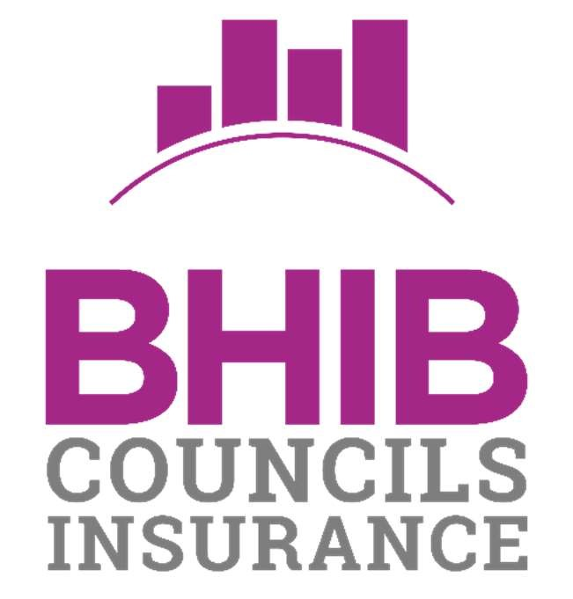

BHIB Councils Insurance is a trading name of BHIB Limited. Registered office is AGM House, 3 Barton Close, Grove Park, Enderby, Leicester LE19 1SJ. BHIB Limited is registered in England and Wales number: 829660. Authorised and regulated by the Financial Conduct Authority (116675). You can check this by visiting https://register.fca.org.uk

