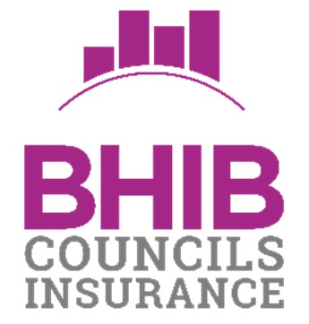
Local Councils Insurance
Special Events & Activities Guidelines

Firework Displays / Bonfires / Beacons

If you organise a firework display or bonfire/beacon, you must:

- consult the relevant authorities at least seven days before the event.

- comply with any recommendations or instructions of:

  - the relevant authorities.
  - fireworks manufacturers.

- organise the event in accordance with the latest guidance from the Health and Safety Executive, in particular:

  - storing fireworks in a safe manner.
  - keeping spectators a safe distance away from the display and bonfire.
  - providing an adequate number of marshals or stewards to control spectators.
  - having available means of extinguishing a fire.
  - providing sufficient first aiders.

- obtain fireworks from a reputable manufacturer

- not modify or adapt fireworks

- ensure the display and bonfire is at least 20 metres away from premises or vehicles which you do not own, hire or rent or any flammable or other dangerous materials

If it is not possible to comply with these guidelines for any reason, please contact the BHIB Councils Insurance team for further advice.

Christmas Trees and Lights

The tree is to be erected by a competent person

- Electrical devices to be connected to mains supply by a qualified electrician with their own
Public Liability Insurance
- If the tree is erected on land not owned by the Policyholder, the landowner concerned must have their own Public Liability Insurance
- The tree must be regularly inspected especially in cases of bad weather

Bouncy Castles and Inflatables

If the Insured hires or operates inflatable equipment the Insured must

- ensure all operators have sufficient training and knowledge to understand the procedures and rules regarding the safe use and operation of such devices.
- Follow the manufacturers’ or suppliers’ guidelines in relation to the maximum number of persons allowed in or on such devices at any one time.
- Ensure all outdoor devices have adequate anchorage points that must be used at all times.
- Inspect all devices daily prior to use and at least annually by a competent person. All defects that are a risk to health & safety must be rectified immediately or the device must be taken out of use until repaired.

Where inflatable equipment is hired in, the Insured must

- have in place a system of check to ensure that the supplier has Public and Products Liability insurance, which must not be less than the limit provided to the Insured by this Policy.
- keep written details of such insurance including the policy number, insurer and the limit of liability.

Shooting and Archery

- Each firing position must be individually supervised and controlled by experienced and qualified persons
- An area behind the firing position must be roped off ensuring any person not involved has no access whatsoever
- Owners of guns must have their own Public Liability Insurance
- No unauthorised persons are to use the guns

Fetes and Galas

- Police and Fire Brigade authorities must be consulted at least 7 days prior to the event, and again, their recommendations strictly adhered to
- There should be at least 1 steward in attendance for every 100 spectators for the duration of the event
- Qualified First Aid personnel must be in attendance with the means available to summon the
Emergency Services
- All independent persons, owners of mechanically propelled vehicles and the owners of any animals must have their own Public Liability Insurance
- The Policyholder must ensure that all areas where events are to take place are suitable for their intended purpose

Playgrounds

In respect of all playground equipment and other amusement devises the Insured must

- Inspect all playground and amusement devises at least every seven days. Any damage or defect must be rectified as soon as possible. Defective equipment which is a risk to health and safety must be taken out of use immediately and repaired as soon as possible.
- Erect suitable signs detailing any information that is necessary for the safe use of the equipment device or facility and clearly stating any restrictions on its use.
- Determine where supervision is necessary and ensure that it is provided whenever the play equipment device or facilities are in use.

Boating ponds and Lakes

In respect of the hiring out of non-powered boats, the Insured must

- Inspect the boats daily and rectify any defect as soon as possible. Any defective boat that is a risk to health and safety must be taken out of use immediately and repaired as soon as possible
- Supervise the use of boats at all times and persons misusing the boats must be ordered to return to land
- Provide life jackets free of charge to hirers of sailing boats and encourage hirers to wear them.
- Have a motorised rescue boat, in workin9 order, ready for use at all times.
- Have life-saving equipment and the means of summoning emergency available at all times

Any other hazardous activity not previously mentioned must, of course, be notified to your BHIB insurance advisor, prior to the activity taking place.

BHIB Councils Insurance - Team Contacts

Address: BHIB Ltd, AGM House, 3 Barton Close, Grove Park, Enderby, Leicester LE19 1SJ
Telephone: 0330 013 0036
Email: enquiries@bhibcouncils.co.uk

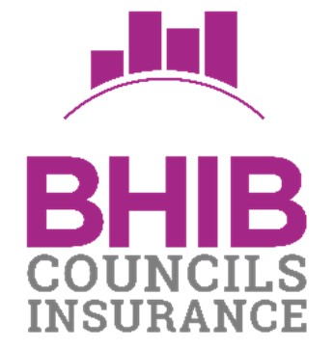
Local Councils Insurance Special Events & Activities Guidelines v21.10.19

