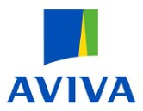
Certificate of Employers' Liability Insurance (a)
(Where required by regulation 5 of the Employers’ Liability (Compulsory Insurance) Regulations 1998, one or more copies of this certificate must be displayed at each place of business at which the Policyholder employs persons covered by the Policy)
Policy Number: | 100723637BDN/LCO02965
Name of Policyholder: | Ashwellthorpe and Fundenhall PC
Date of commencement of insurance | 30/05/2023
Date of Expiry of insurance | 29/05/2024

We hereby certify that subject to paragraph 2:
- the policy to which this certificate relates satisfies the requirements of the relevant law applicable in Great
Britain, Northern Ireland, the Isle of Man, the Island of Jersey, the Island of Guernsey and the Island of
Alderney, or to offshore installations in territorial waters around Great Britain and its Continental Shelf (b)
- the minimum amount of cover provided by this Policy is no less than £5 million (c)

Signed on behalf of
Aviva Insurance Limited
(Authorised Insurers)
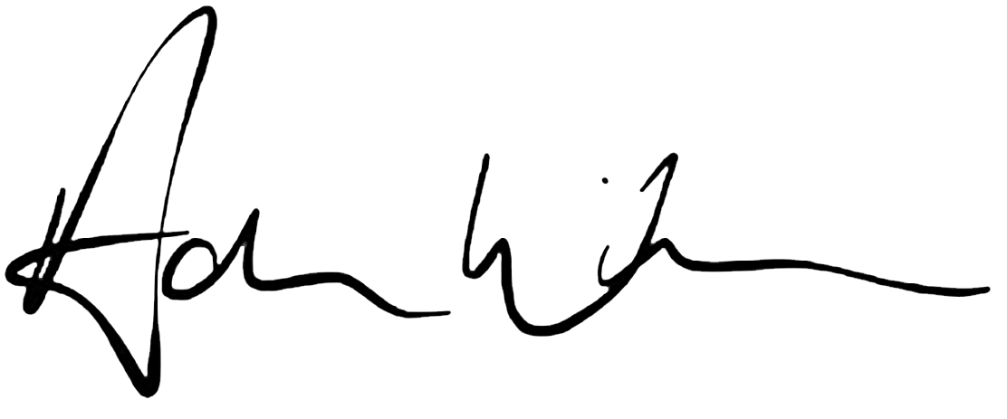
Authorised Signatory
Adam Winslow
Chief Executive Officer, UK & Ireland General Insurance

Notes
- Where the employer is a company to which regulation 3(2) of the Regulations applies, the certificate shall state in a prominent place, either that the policy covers the holding company and all its subsidiaries, or that the policy covers the holding company and all its subsidiaries except any specifically excluded by name, or that the policy covers the holding company and only the named subsidiaries
- Specify applicable law as provided for in regulation 4(6) of the Regulations.
- See regulation 3(1) of the Regulations and delete whichever of paragraphs 2(a) or 2(b) does not apply. Where 2(b) is applicable, specify the amount of cover provided by the relevant policy.
It is recommended that you retain a copy of each Employers’ Liability certificate issued to you
Arranged by BHIB Insurance Brokers. Registered in England & Wales No 829660. Authorised and regulated by the Financial Conduct Authority. A Brokerbility Company.
Underwritten by Aviva Insurance Limited. Registered in Scotland No 2116 Registered Office Pitheavlis, Perth, PH2 0NH. Authorised by the Prudential Regulation Authority and regulated by the Financial Conduct Authority and the Prudential Regulation Authority
Page 1 of 1

