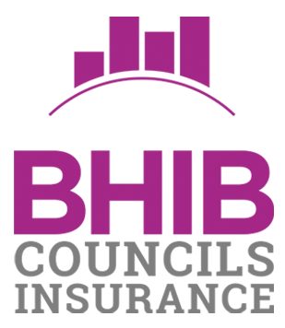
Brokers Certificate of Public and Products Liability Insurance

Name and Address of Insured | Ashwellthorpe and Fundenhall PC  86 Vanguard Chase  Norwich  Norfolk  NR5 0UH
Insurers | Aviva Insurance Ltd, Pitheavlis, Perth PH2 0NH
Policy Number | LCO02965
Period of Insurance | From: 30 May 2023  To: 29 May 2024
In our capacity as Insurance Brokers we hereby certify that | the above named are currently insured for the above period.
The limits of indemnity currently provided are as follows:  Public and Products Liability  £10,000,000 any one incident (or in total during any one per | iod of insurance in relation to Products Liability)
The cover provided is in accordance with the terms and con | ditions agreed with the insurer. Details can be provided on
request. The information provided is accurate at the date of any alterations. | issue. No obligation is imposed on the Broker to advise of
Broker Details | BHIB Insurance Brokers  AGM House, 3 Barton Close, Grove Park, Enderby, Leicester LE19 1SJ
Signed | 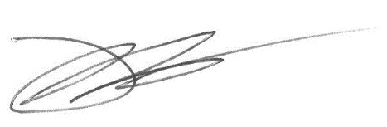
Name | Kevin Richards – Cert CII – Head of Technical Broking
Date of Issue | 30 May 2023

